EXAMINATION POLICY (ASSESSMENT POLICY)

Exam System
* The school session has been divided into two (2) terms :
- First term from August to December
- Second term from January- June

* Each term has two exams,
- Monthly Exams
- Second Monthly Exams (2nd Semester)
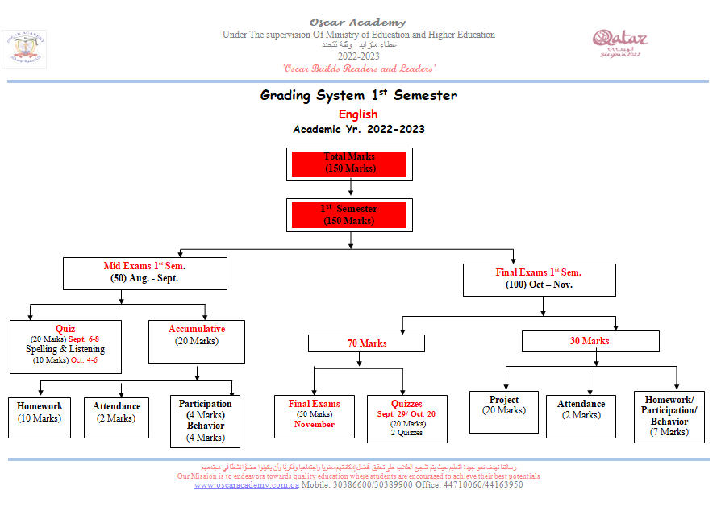
- Final Semester Exams (1st and 2nd Semester)

Distribution of Marks for the Second Monthly, and Final Semester Exams
Subject | Monthly October | Semester | Monthly | Final
 |  | December | March | June
English | 50 | 150 | 50 | 150
Math | 50 | 150 | 50 | 150
Science | 50 | 150 | 50 | 150
Social | 50 | 150 | 50 | 150
Arabic | 50 | 150 | 50 | 150
Religion | 50 | 150 | 50 | 150
Religion in English for  non native | 50 | 150 | 50 | 150
Road to Success for  Non Muslim | 50 | 150 | 50 | 150
Computer | 50 | 50 | 50 | 50
Q. History | 50 | 50 | 50 | 50
French( from year 3 to 6) | 50 | 50 | 50 | 50
Art | 50 | 50 | 50 | 50
Physical Education | 50 | 50 | 50 | 50
*Arabic, Religion and QH Exams are patterned according to the guidelines set by the MOEHE.
*Other subjects like English, Math and Science are based according to the standards by the Uk curriculum

Type of Exams:
    - Entrance test
    - Diagnostic Examination
    - Formative Exams:
The goal of formative assessment is to monitor student learning to provide ongoing feedback that can be used by teachers to improve their teaching and by students to improve their learning. Formative assessments are generally low stakes, which means that they have low or no point value.
- Quizzes
- Spelling
- Mental math
- Oral
- Small competitions among students groups
Summative Exams:
The goal of summative assessment is to evaluate student learning at the end of an instructional unit by comparing it against some standard or benchmark.
Summative assessments are often high stakes, which means that they have a high point value.
- Diagnostic test
- Monthly exam
- Semester exam
- Projects
- Dictation
- Oral Exam
- Mental Math
International Exams:
It is important for us to evaluate student level with international exam and analyze the results to improve the weaknesses if any.
- Students participate in TIMSS/PERLS when ever conducted to compare the level of students in Math and English
- Students also participated in Granada Learning (GL Exam) .GL Assessment is the leading provider of formative assessments to UK schools, as well as providing assessments for overseas ministries and British, bilingual and international schools in over 100 countries worldwide. This exam provides us analysis to check the level of student in English and compare to other countries.
Academic Result
Academic result is send to the parents after each exams followed by the parents’ teacher meeting to discuss the progress of the student. (Except for Final Exams)

MONTHLY AND SEMESTER EXAM REPORT CARD:
Monthly and semester report card has marks from the exam and class accumulative marks added together.

Final Exam Report Card:
The final report card reflects the overall performance of a child throughout the year. It includes the marks from first semester as well as second semester. The child is graded on combine marks of both the semester.
Sample report card:
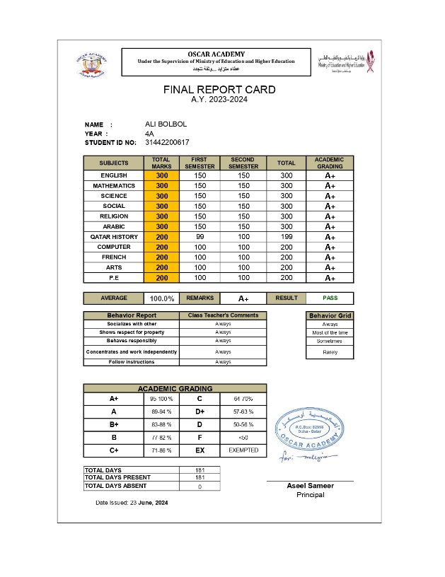

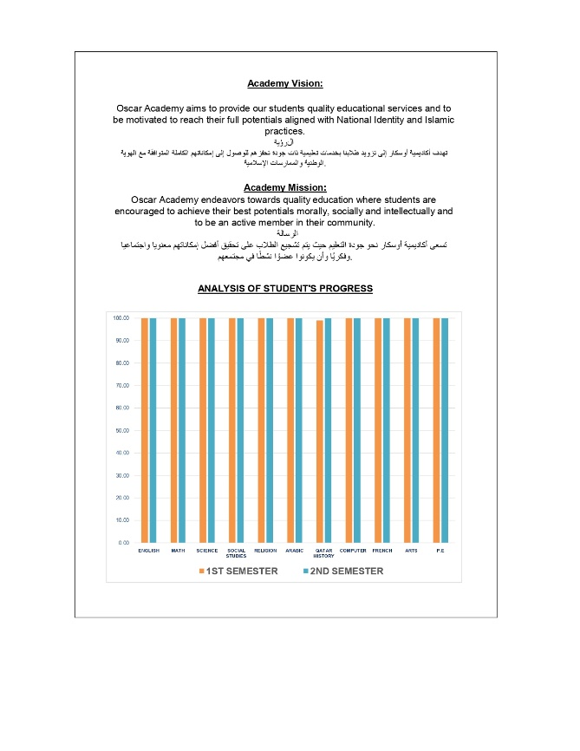

Behavior Report

Monthly Behavior Report is given to Parents every month to sign and write comments if there is any concern during the Parent’s-Teachers conference.
Sample:

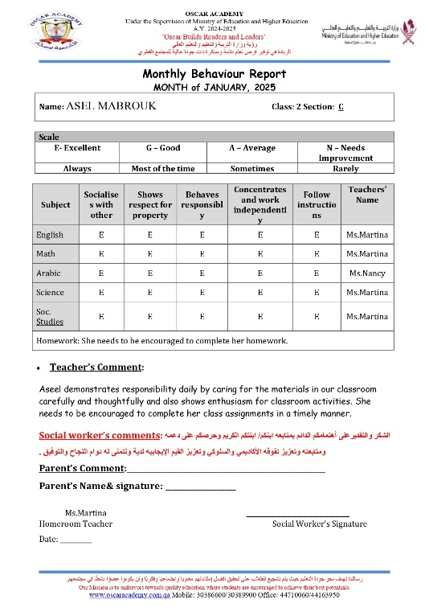
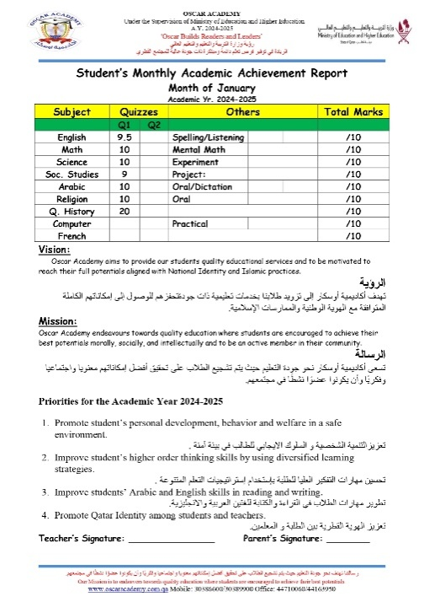

Class Accumulative Marks:
Class accumulative marks are included in monthly as well as semester exam. The accumulative marks are distributed among the following:
- Quizzes
- Projects
- Dictation
- Oral exam
- Mental math
- Spellings
- Class participation
- Homework
- Discipline
- Attendance

Sample accumulative:
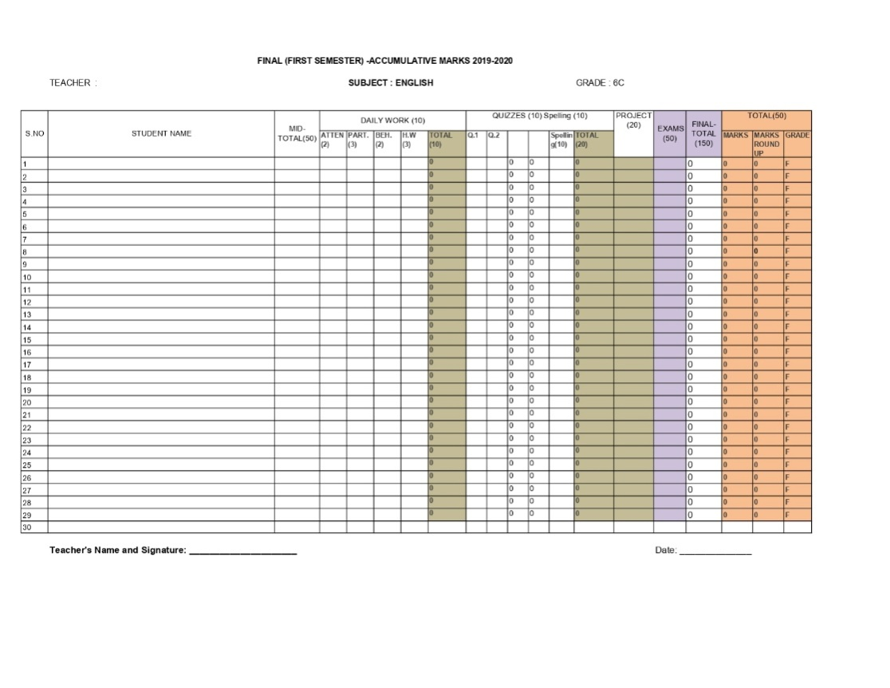

Absentees:
For any student absent from the exam following policy will be followed.
- No special exam is given without approval from the school.
- Student absent due to medical reason must provide medical certificate from Hammad hospital. Rexam will be conducted for the student
- A student travelling for emergency must get the approval from the school. Rexam will be conducted for the student
Collection of Examination paper
- Teachers and coordinators will be sent a memo regarding exam paper with due date.
- Coordinator will check and edit the exam paper and email it to Academic Vice-Principal for approval. Academic VP will check the exam papers and submit to the Principal for final approval. Exam papers will be returned to the Team leaders for the feedback made by the SMT .
- Coordinator and teacher assigned will make the desired changes and send the paper back to the Academic Vice Principal for Answer key and Printing.
- Teachers will be called to make an answer key for all the papers.
- After answer key is made, changes will be made for any mistake if found in the paper.
- Paper will be printed again after changes for filing.
- Final paper will be printed and filed and for photocopy.
- Photocopy will be made and paper will be sealed in envelopes in the presence of Academic Vice-Principal.
- Papers will be locked in Academic Vice-Principal’s office. Keys will remain with the AVP.

Distribution and collection of Exam papers on Examination Day:
- Teachers will be assigned with an exam room in a duty paper.
- Exam paper distribution is assigned to the committee.
- Papers are distributed 10 mins before the exam to the building Supervisors.
- Papers are collected as soon as it is finished.
- Building Supervisor will count the papers and hand over to exam committee.
- Papers will be counted again in presence of Academic Supervisor in her office.
Papers will be shifted to checking room.

Monitoring Of Examination:

- Examination committee will take a round during exam to monitor exam.
- For any issue regarding exam paper Academic Supervisor should be called.
- Academic Supervisor will resolve the issues.
- If subject teacher is required, she/he can be called after informing the exam committee.

Checking Procedure:

- Teachers will be assigned with checking and rechecking.
- Teachers will use red pen for checking and green/blue pen for rechecking
- Teachers are provided with the specific answer keys, rubrics and criteria for checking in each subject.
- After rechecking coordinators and AVP will recheck randomly Exam papers.
- For any dispute in checking or answer AV’s decision will be final.
- Marks will be recorded in accumulative by the subject teacher.
- After checking procedure exam will be shifted to the Exam’s room.
Exam and Promotion Policy
To ensure a fair, transparent, and consistent approach to student promotions, examinations, and academic progress in alignment with the Ministry of Education and Higher Education’s standards. The policy aims to support student success, hold students accountable for their academic performance, and maintain clear guidelines regarding exams, promotions, and attendance.

Category | Details
Promotion Criteria | - A student must secure at least 50% in each subject and 50% in aggregate to be promoted to the next class.
 | - A student failing in more than two core subjects (English, Math, Science, Social Studies, Religion, Arabic) will not be promoted.
 | - Students who miss any term due to late admission or approved medical leave will have their following terms’ weightage adjusted accordingly.
Re-test Policy | - Students failing in two or more subjects will be offered a re-test for the failing subjects. Parents will receive a letter about this.
 | - Promotion will be granted only after meeting the re-test and promotion criteria.
Attendance Policy | - Students with less than 90% attendance will not be allowed to sit for the final exam.
 | - Students who are absent for the final exam but have passed the accumulative exams will not be promoted unless approved by the Principal/Academic Principal.
Retake Exams | - Retake exams will be conducted for students who fail or are absent with valid approval from the Principal/Academic Principal.
 | - Early exams will not be conducted unless approved by the Principal/Academic Principal.
Medical Leave for Re-exams | - Only medical certificates from Hamad Hospital are accepted to request a re-exam for absent students.
Behavior and Exam Rules Compliance | - Students must comply with the behavior and exam rules during exams. Failure to follow these rules will disqualify the student from taking the exam.
Reviewing of Exam Papers by Parents | - Parents can request to review their child’s exam papers within one week of the result being issued. Requests must be in writing.
 | - The Academic Vice Principal will review the papers, and parents will be invited to the library between 1:00 p.m. and 2:00 p.m. within two days of the request.
 | - Parents cannot use mobile phones or take photos of the exam papers during the review session.
 | - For any errors or issues, parents will provide comments, and the Academic Supervisor will discuss them with the respective teachers.
 | - If any changes to the result are made, a new result card will be issued after approval from the Principal.

